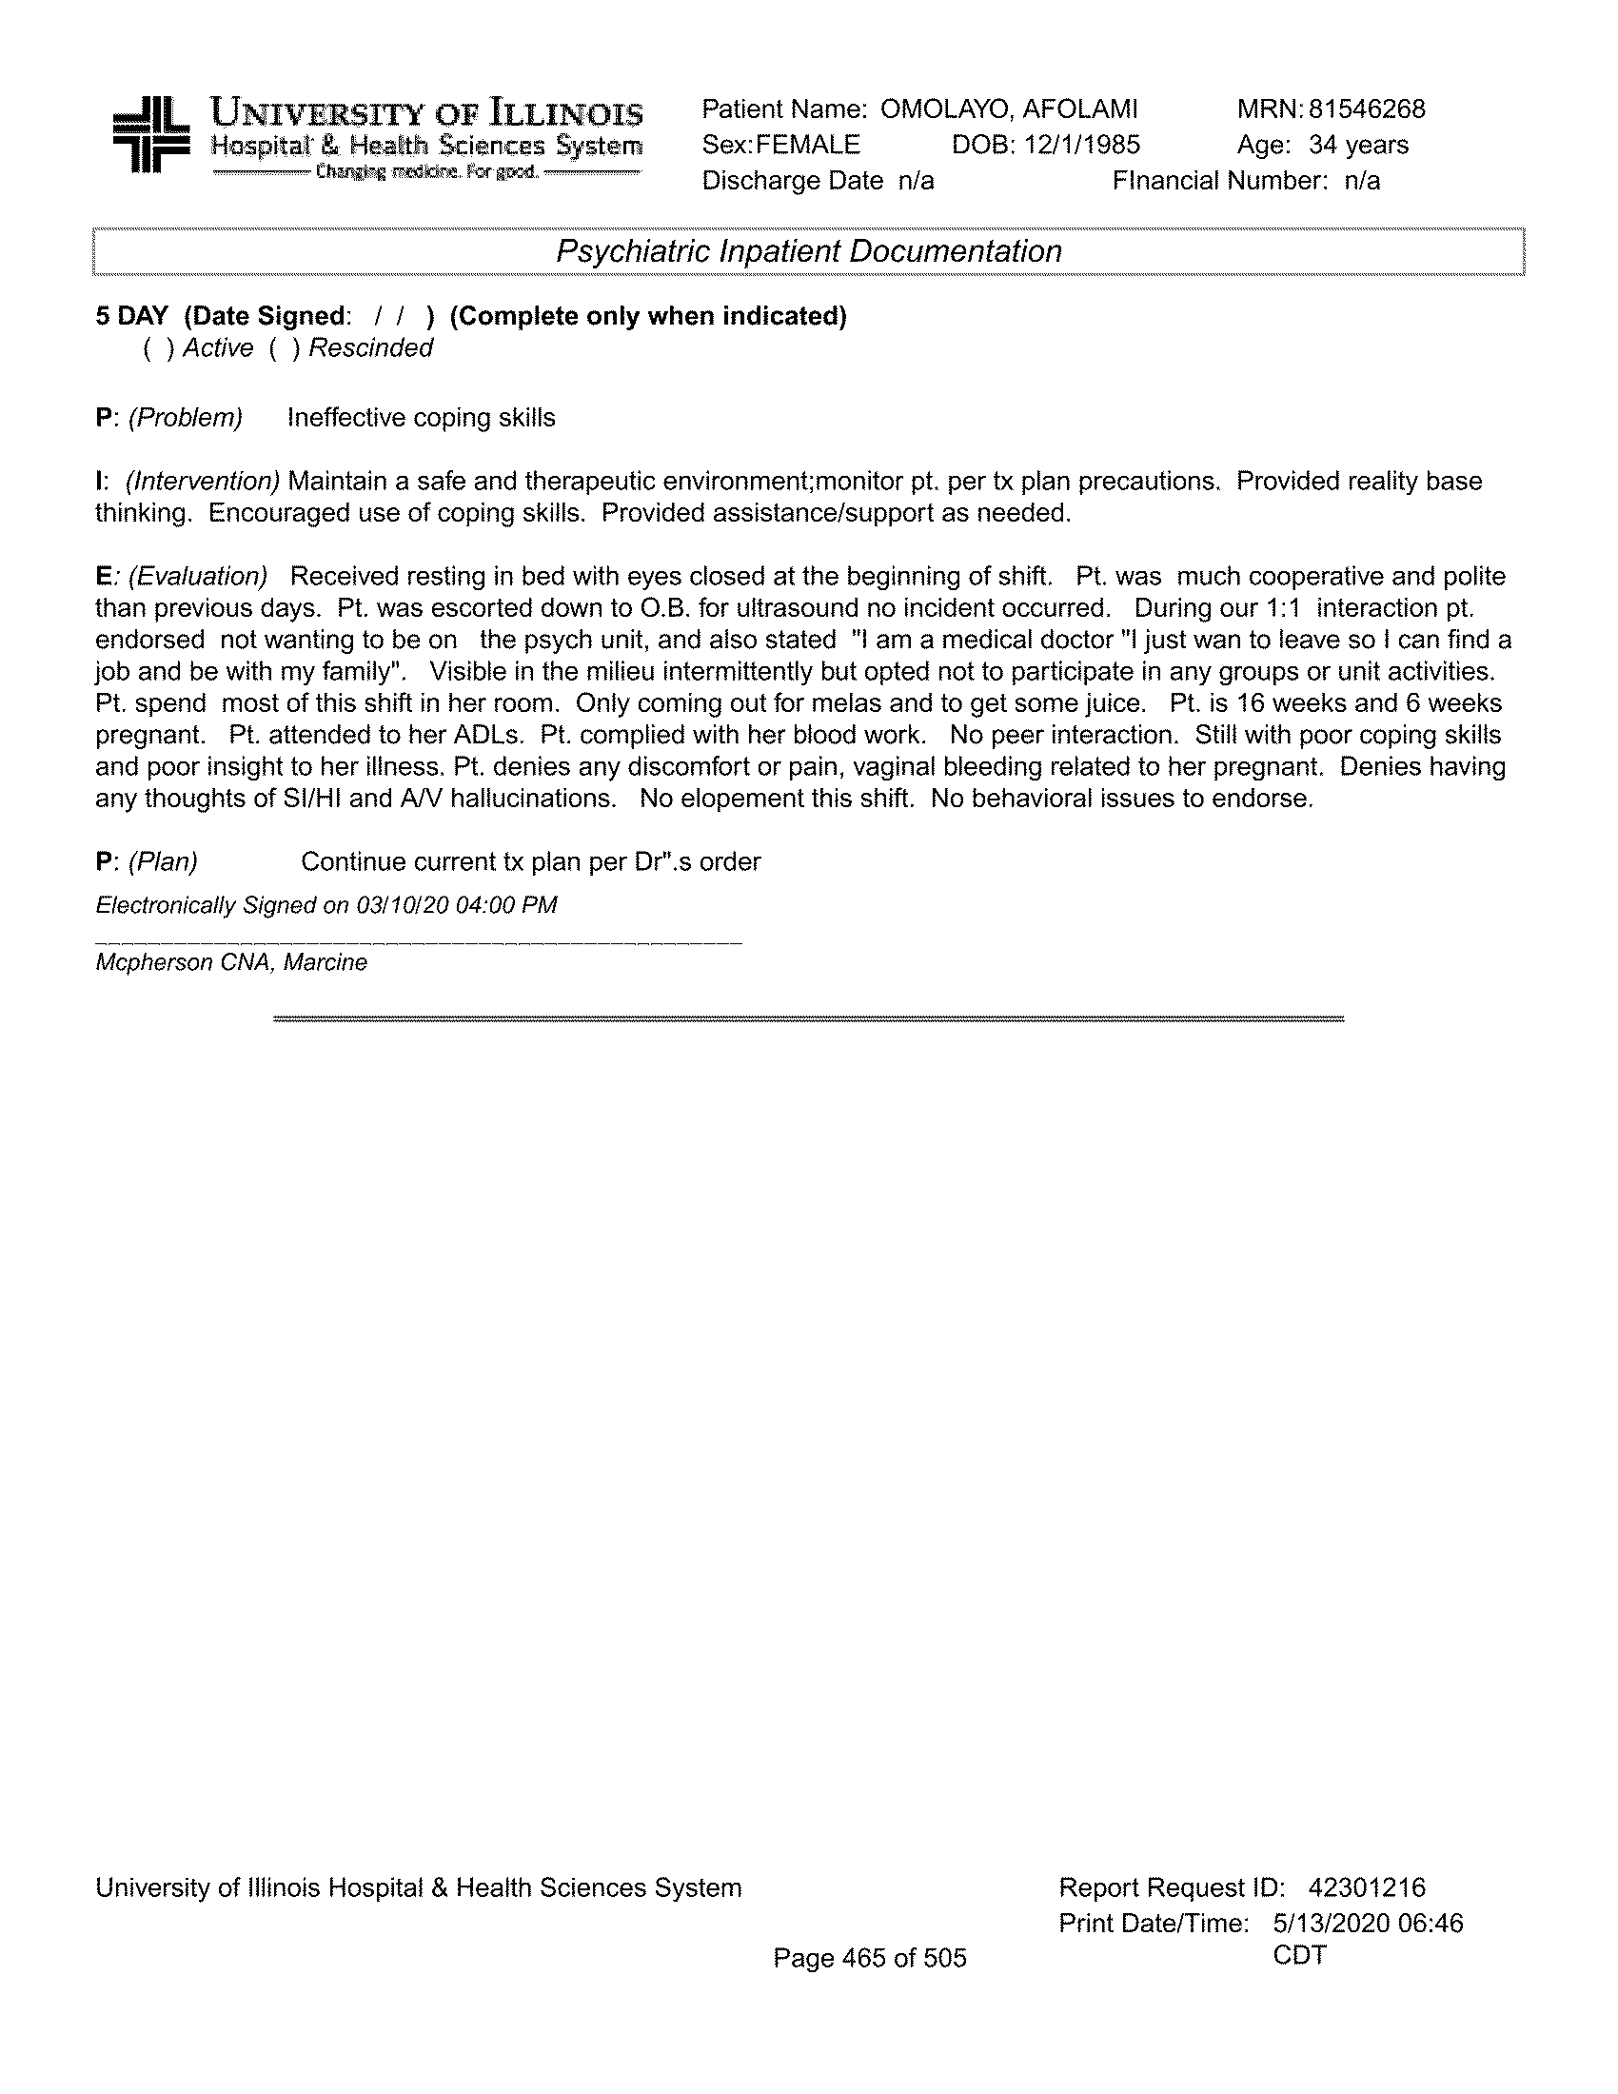

**~~CONFIDENTIALCONFIDENTIAL CONFIDENTIALCONFIDENTIAL~~**

CONFIDENTIAL CONFIDENTIAL CONFIDENTIALCO

CONFIDENTIAL CONFI CONFIDENTIALCOCOCOCO

CONFIDENTIAL CONF

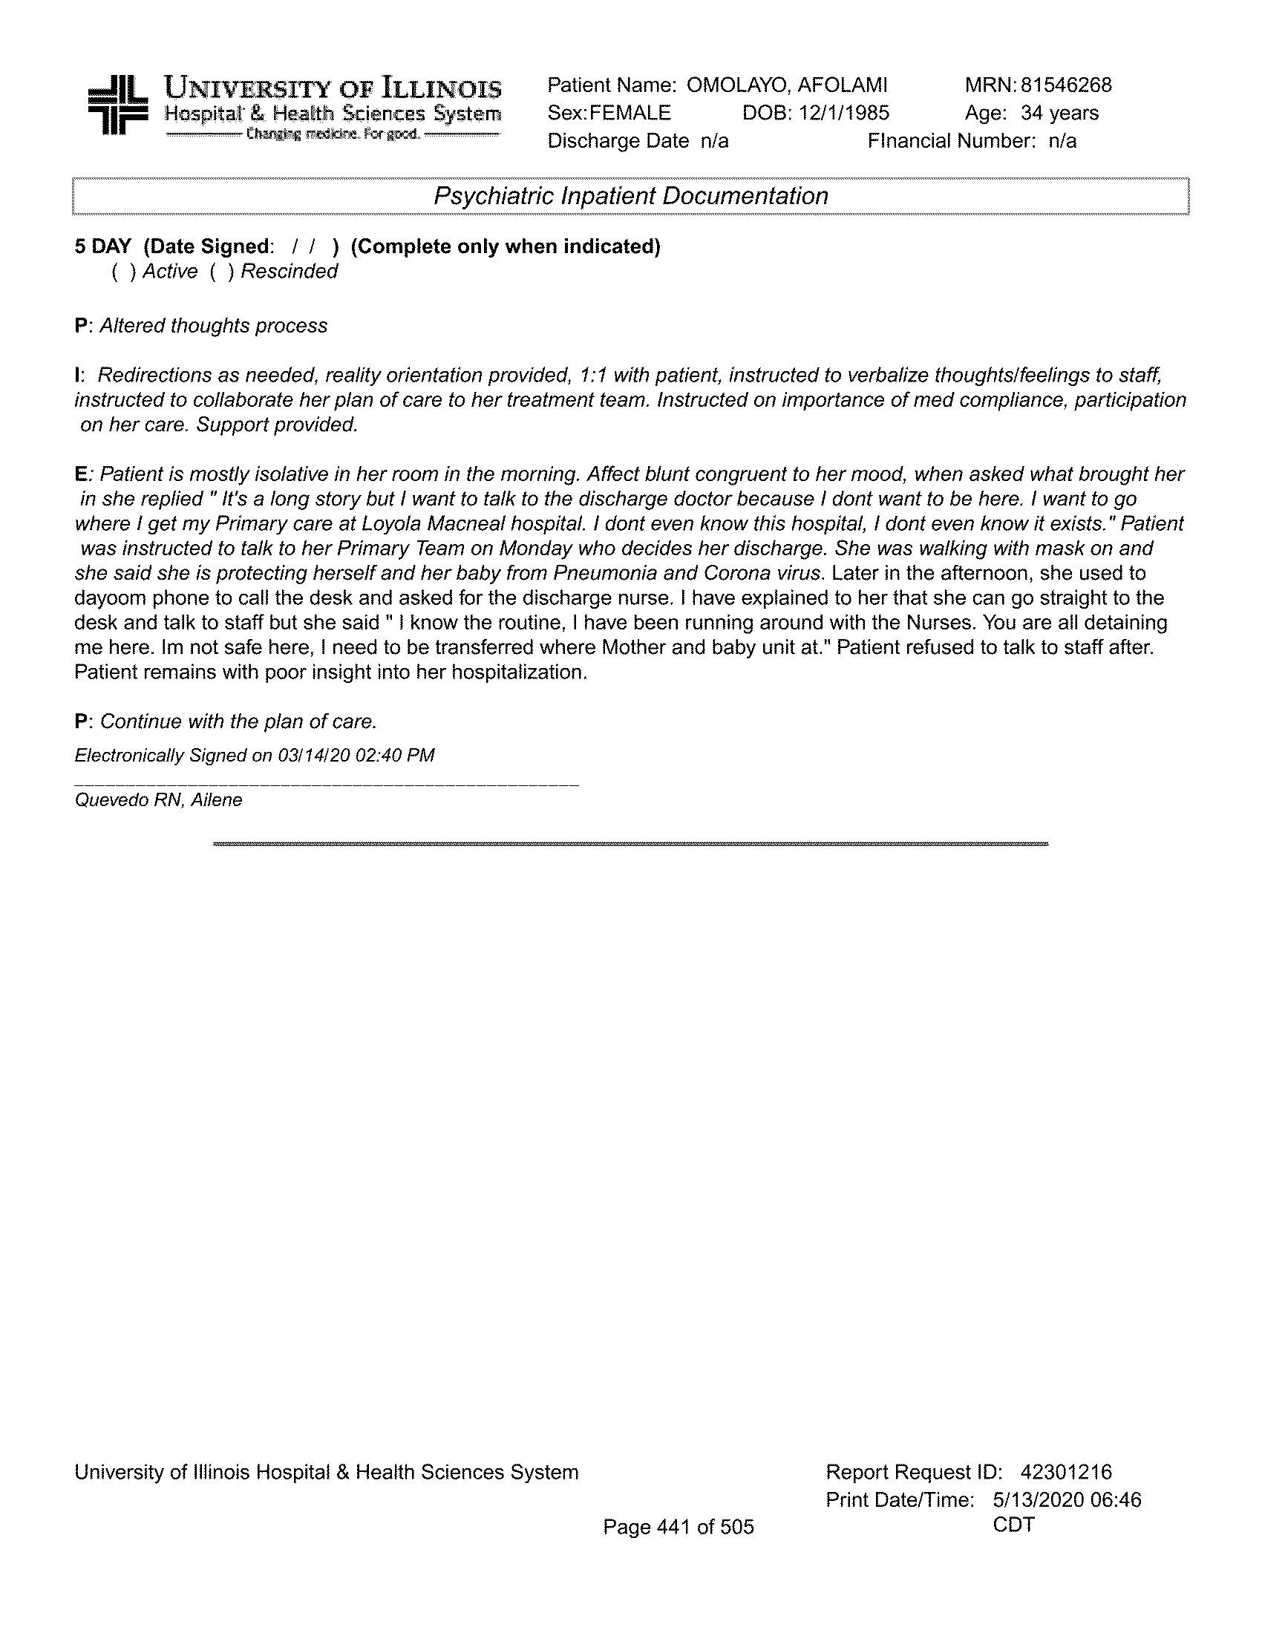

**~~CONFIDENTIALCONFIDENTIAL CONFIDENTIALCONFIDENTIAL~~**

**~~CONFIDENTIALCONFIDENTIAL CONFIDENTIALCONFIDENTIAL~~**

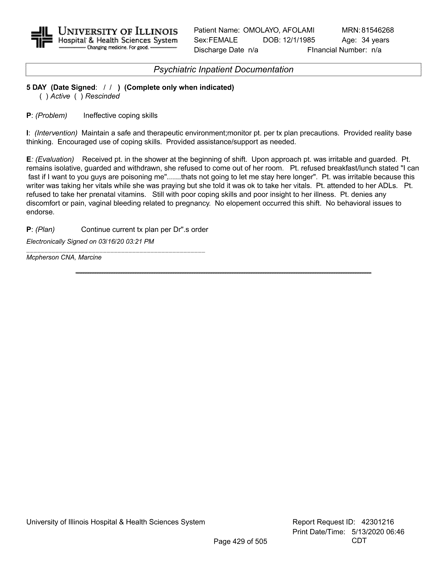

**~~CONFIDENTIALCONFIDENTIAL CONFIDENTIALCONFIDENTIAL~~**

**~~CONFIDENTIALCONFIDENTIAL CONFIDENTIALCONFIDENTIAL~~**

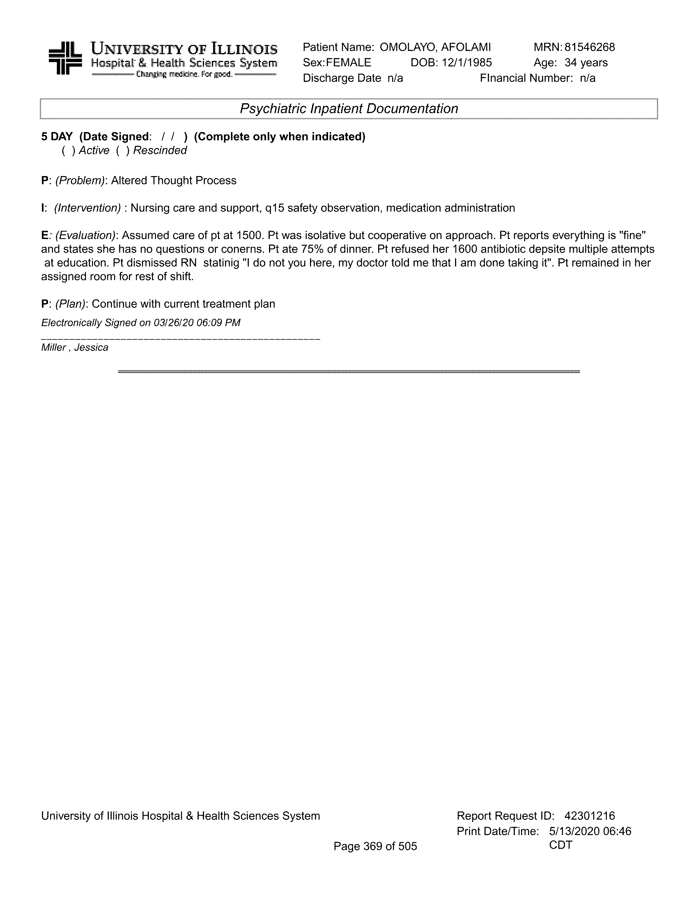

**~~CONFIDENTIALCONFIDENTIAL CONFIDENTIALCONFIDENTIAL~~**

**~~CONFIDENTIALCONFIDENTIAL CONFIDENTIALCONFIDENTIAL~~**

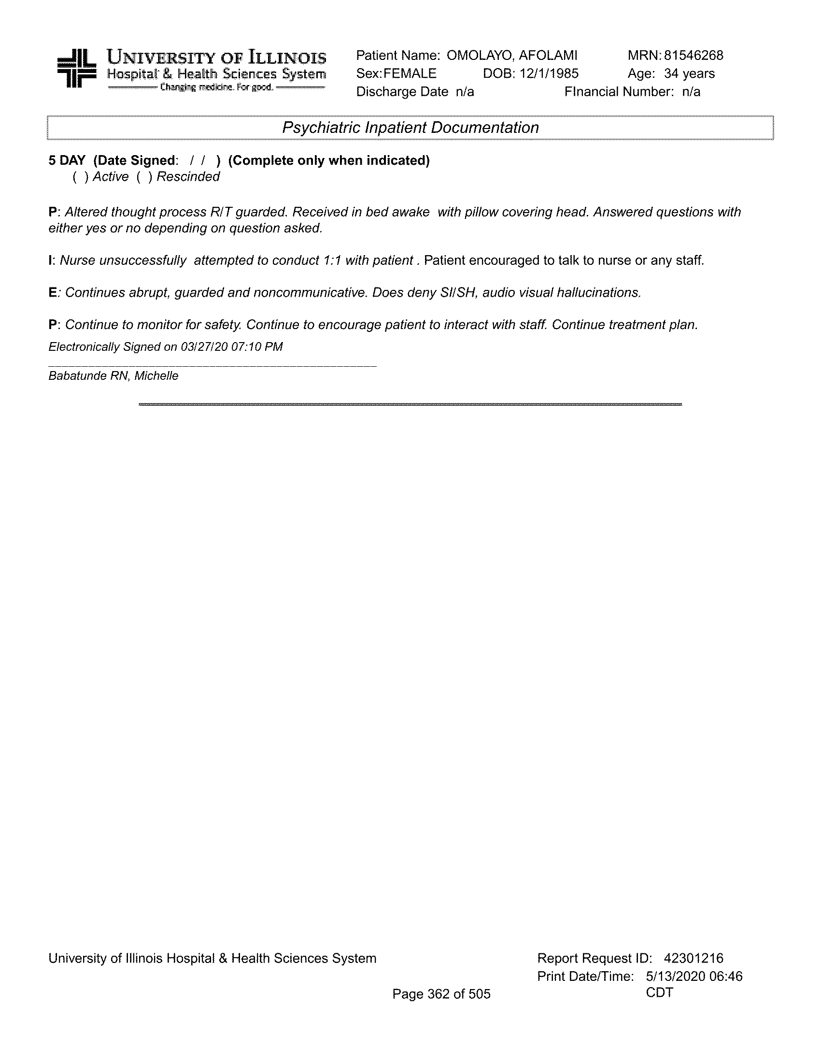

**~~CONFIDENTIALCONFIDENTIAL CONFIDENTIALCONFIDENTIAL~~**

**~~CONFIDENTIALCONFIDENTIAL CONFIDENTIALCONFIDENTIAL~~**

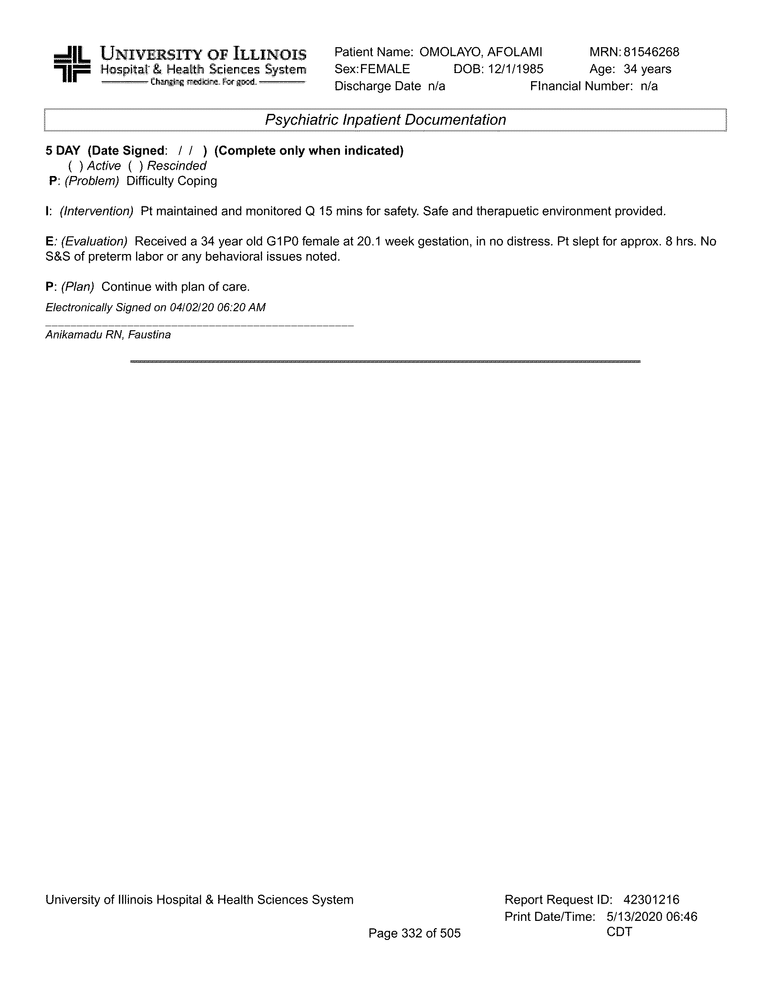

**~~CONFIDENTIALCONFIDENTIAL CONFIDENTIALCONFIDENTIAL~~**

**~~CONFIDENTIALCONFIDENTIAL CONFIDENTIALCONFIDENTIAL~~**

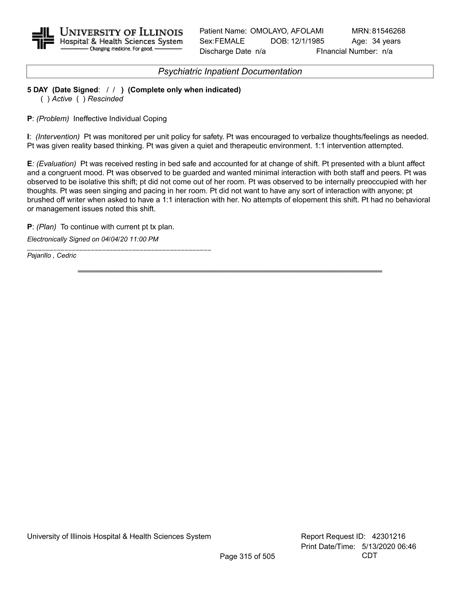

**~~CONFIDENTIALCONFIDENTIAL CONFIDENTIALCONFIDENTIAL~~**

**~~CONFIDENTIALCONFIDENTIAL CONFIDENTIALCONFIDENTIAL~~**

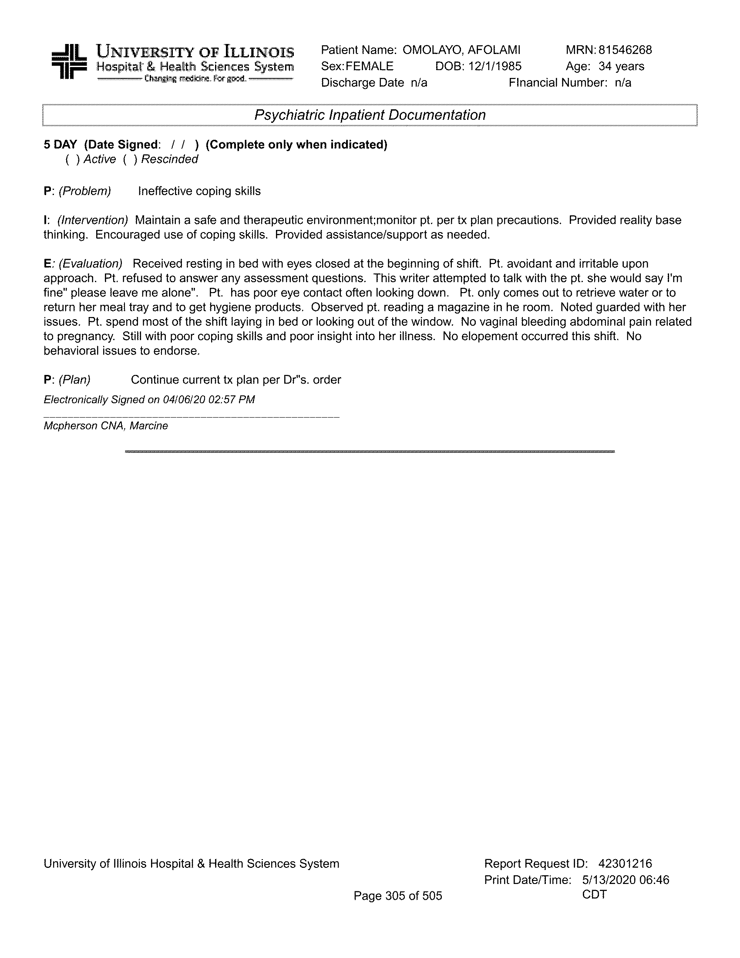

**~~CONFIDENTIALCONFIDENTIAL CONFIDENTIALCONFIDENTIAL~~**

**~~CONFIDENTIALCONFIDENTIAL CONFIDENTIALCONFIDENTIAL~~**

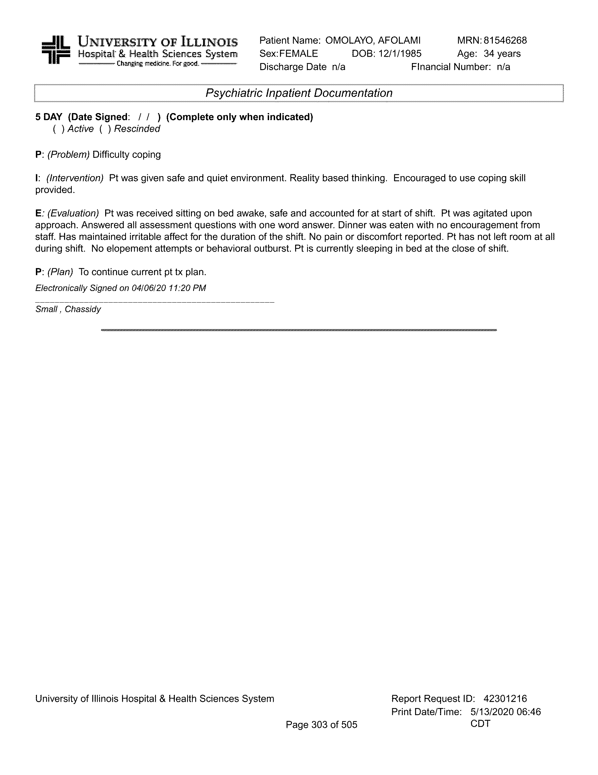

**~~CONFIDENTIALCONFIDENTIAL CONFIDENTIALCONFIDENTIAL~~**

**~~CONFIDENTIALCONFIDENTIAL CONFIDENTIALCONFIDENTIAL~~**

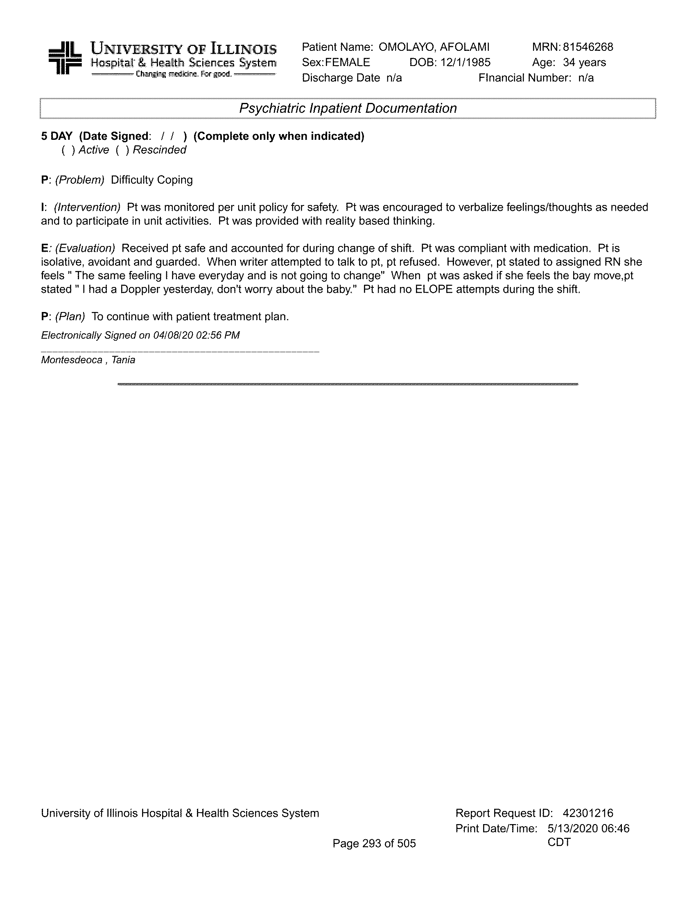

**~~CONFIDENTIALCONFIDENTIAL CONFIDENTIALCONFIDENTIAL~~**

**~~CONFIDENTIALCONFIDENTIAL CONFIDENTIALCONFIDENTIAL~~**

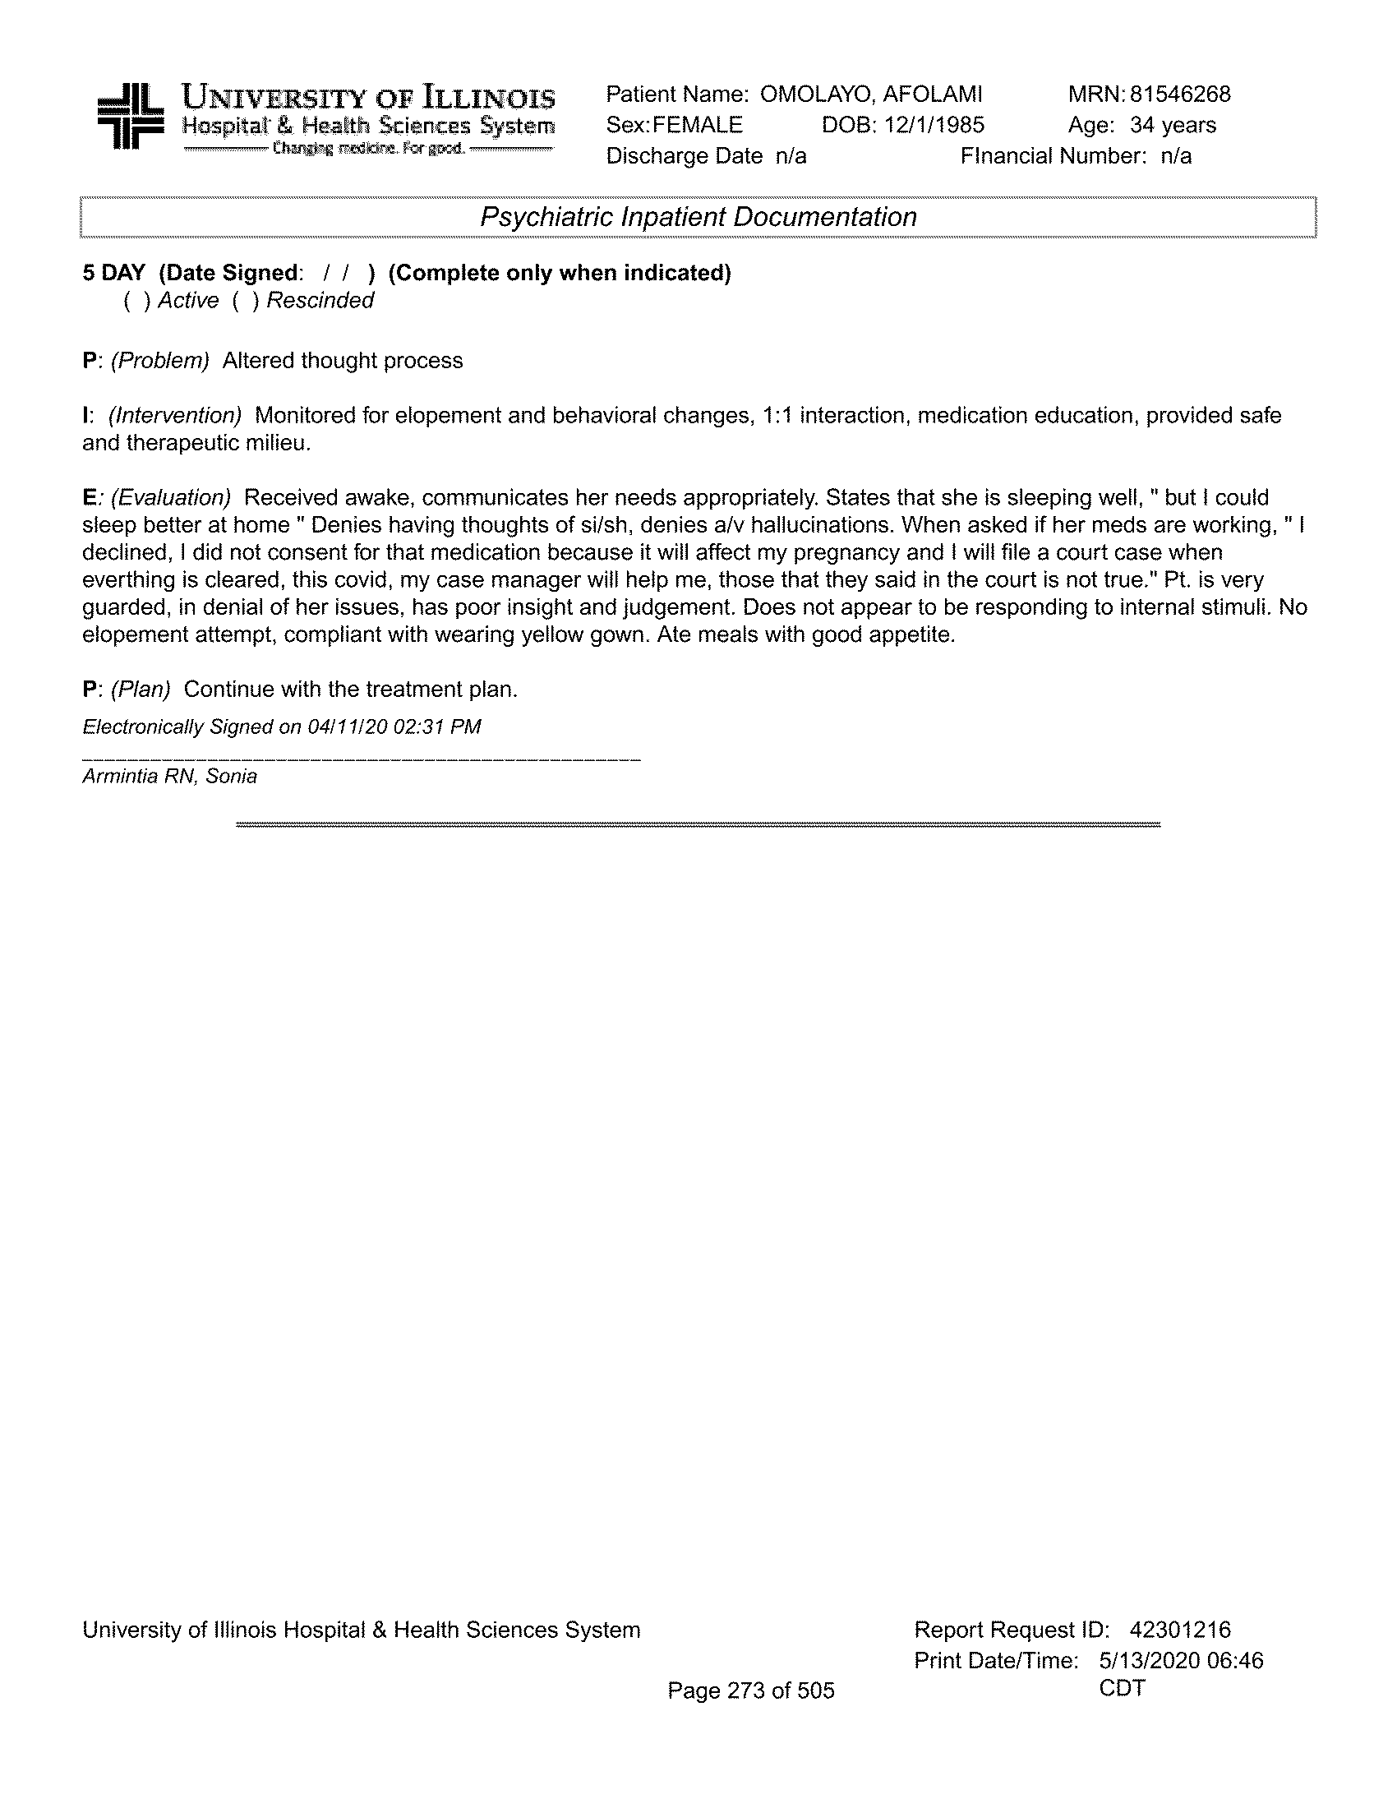

**~~CONFIDENTIALCONFIDENTIAL CONFIDENTIALCONFIDENTIAL~~**

**~~CONFIDENTIALCONFIDENTIAL CONFIDENTIALCONFIDENTIAL~~**

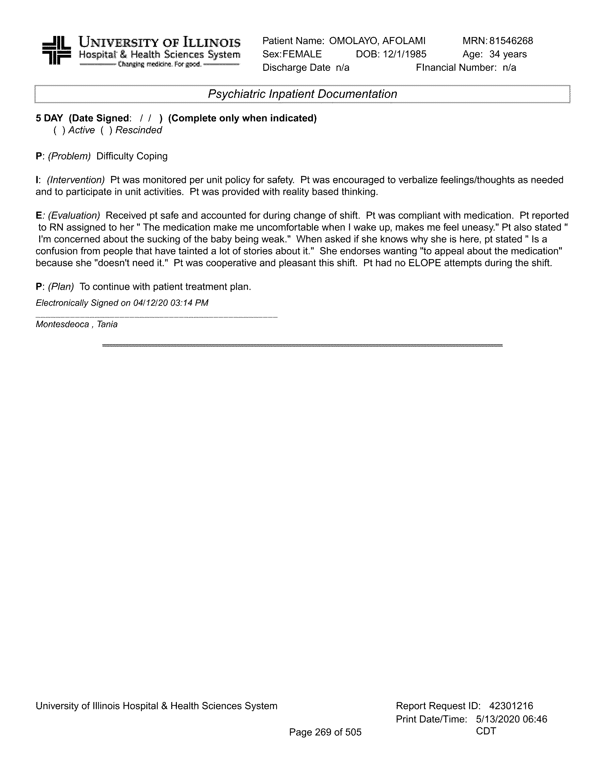

**~~CONFIDENTIALCONFIDENTIAL CONFIDENTIALCONFIDENTIAL~~**

**~~CONFIDENTIALCONFIDENTIAL CONFIDENTIALCONFIDENTIAL~~**

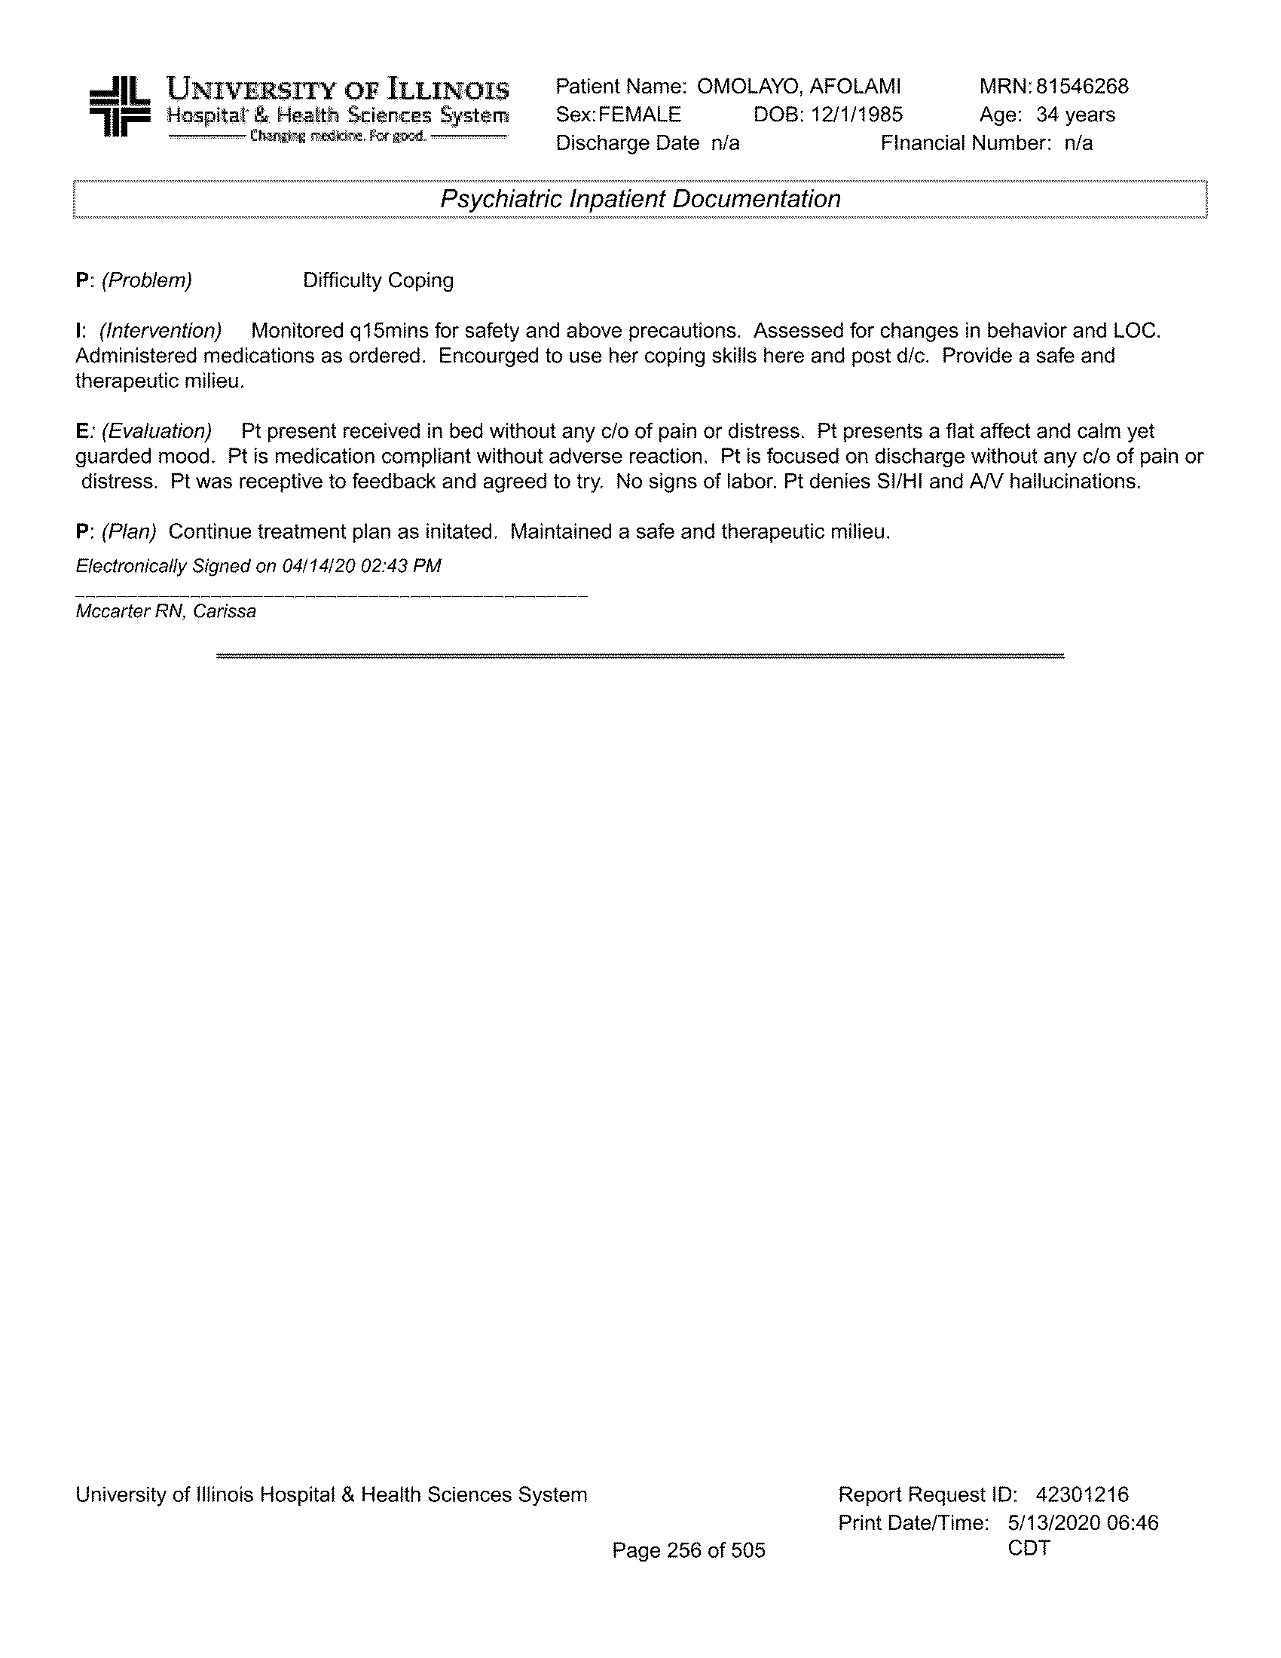

**~~CONFIDENTIALCONFIDENTIAL CONFIDENTIALCONFIDENTIAL~~**

**~~CONFIDENTIALCONFIDENTIAL CONFIDENTIALCONFIDENTIAL~~**

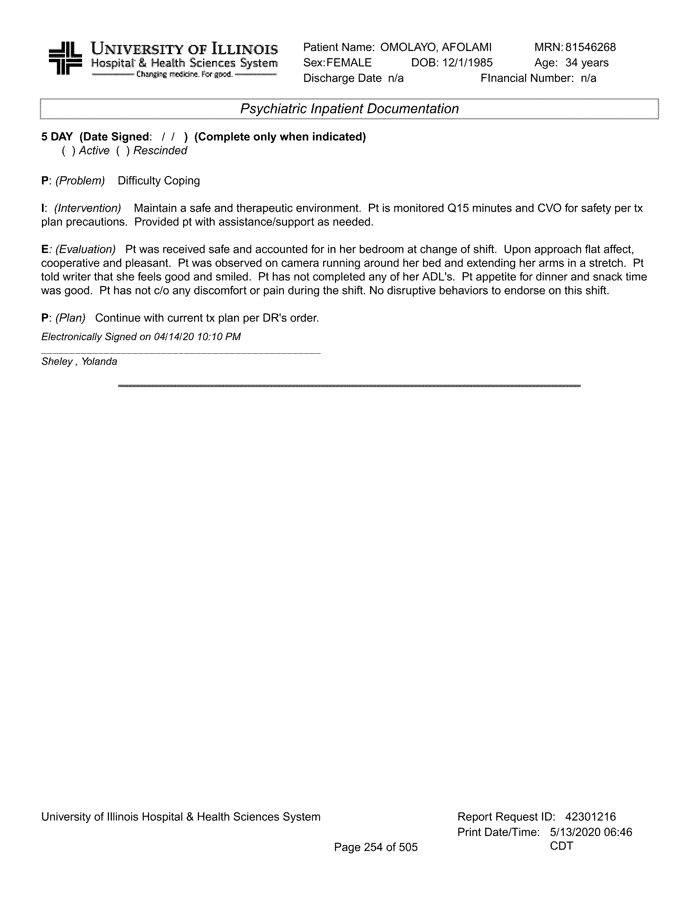

**~~CONFIDENTIALCONFIDENTIAL CONFIDENTIALCONFIDENTIAL~~**

**~~CONFIDENTIALCONFIDENTIAL CONFIDENTIALCONFIDENTIAL~~**

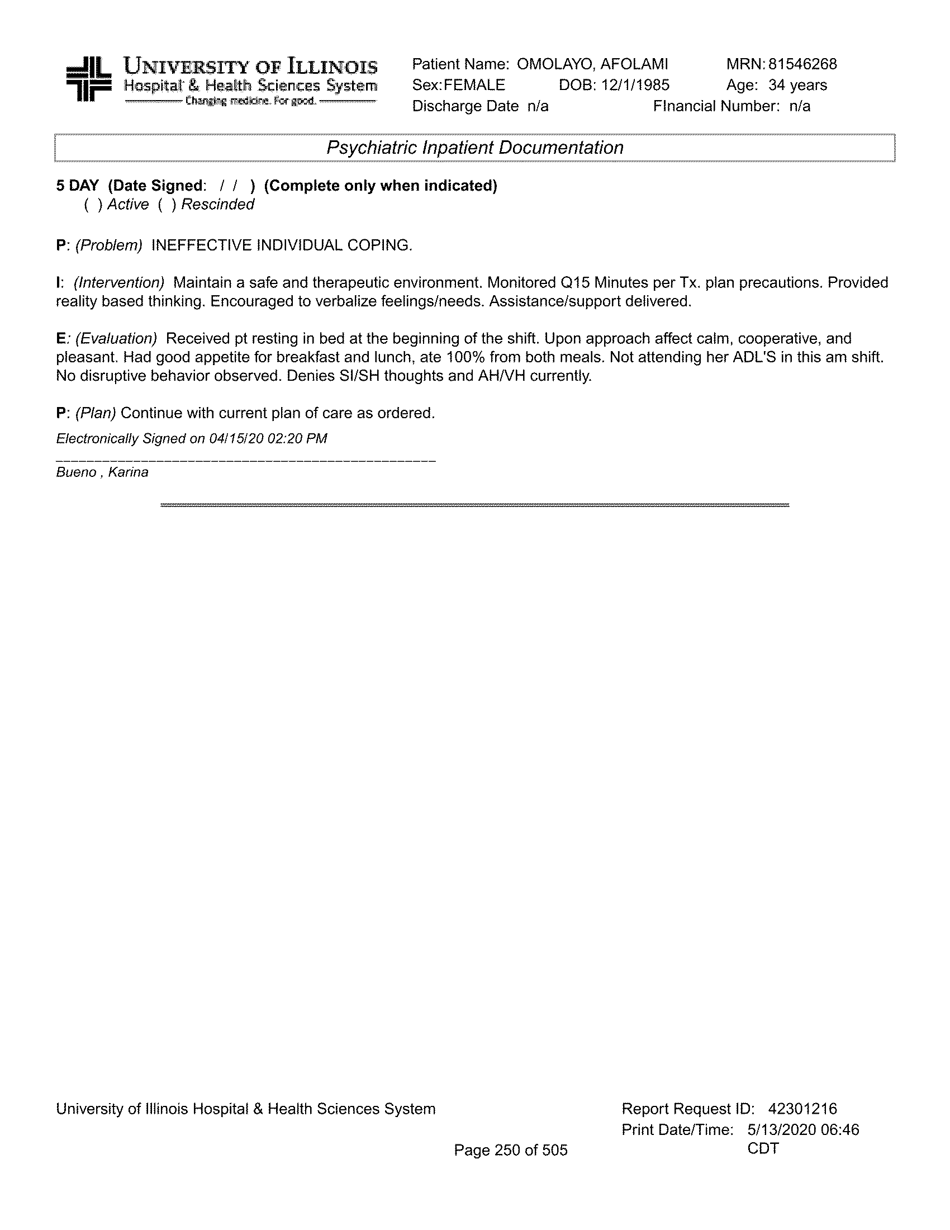

**~~CONFIDENTIALCONFIDENTIAL CONFIDENTIALCONFIDENTIAL~~**

**~~CONFIDENTIALCONFIDENTIAL CONFIDENTIALCONFIDENTIAL~~**

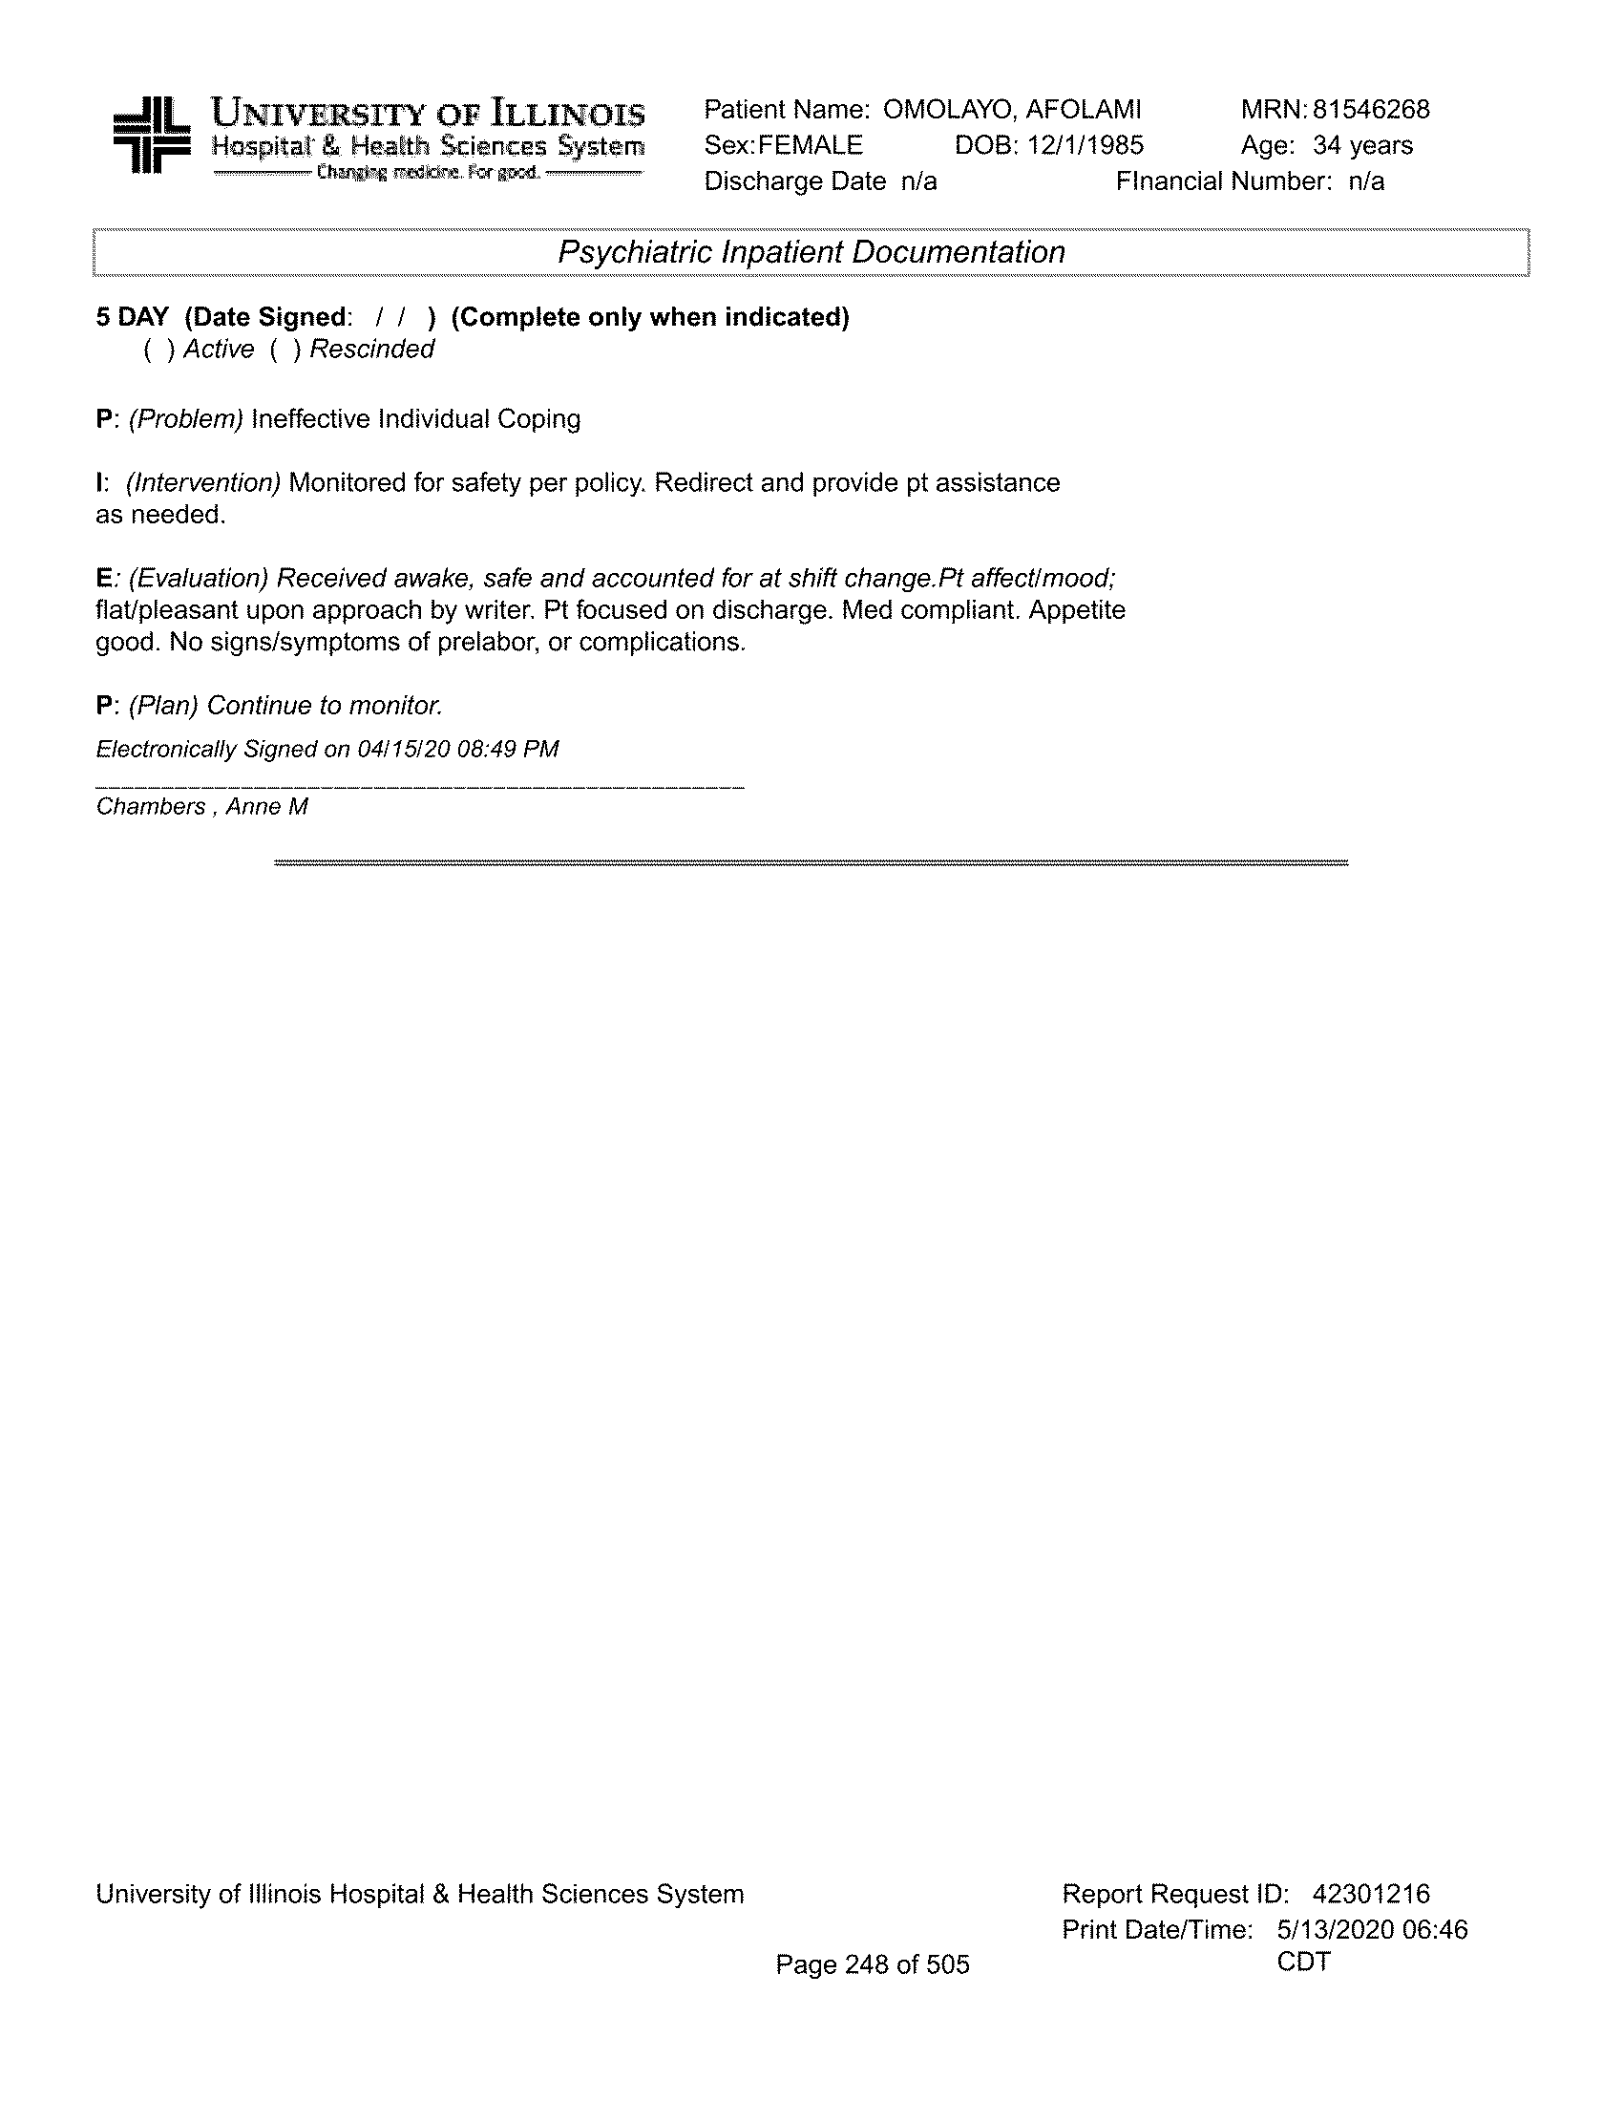

**~~CONFIDENTIALCONFIDENTIAL CONFIDENTIALCONFIDENTIAL~~**

**~~CONFIDENTIALCONFIDENTIAL CONFIDENTIALCONFIDENTIAL~~**

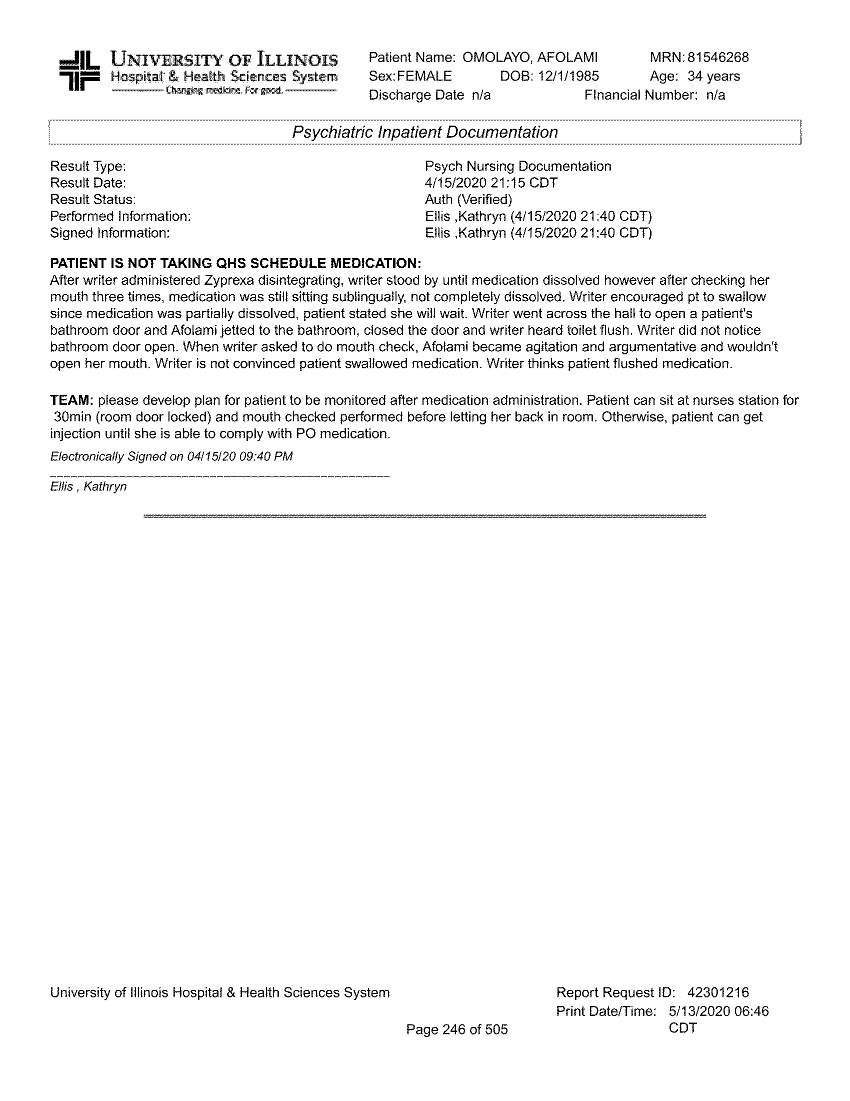

**~~CONFIDENTIALCONFIDENTIAL CONFIDENTIALCONFIDENTIAL~~**

**~~CONFIDENTIALCONFIDENTIAL CONFIDENTIALCONFIDENTIAL~~**

**~~CONFIDENTIALCONFIDENTIAL CONFIDENTIALCONFIDENTIAL~~**

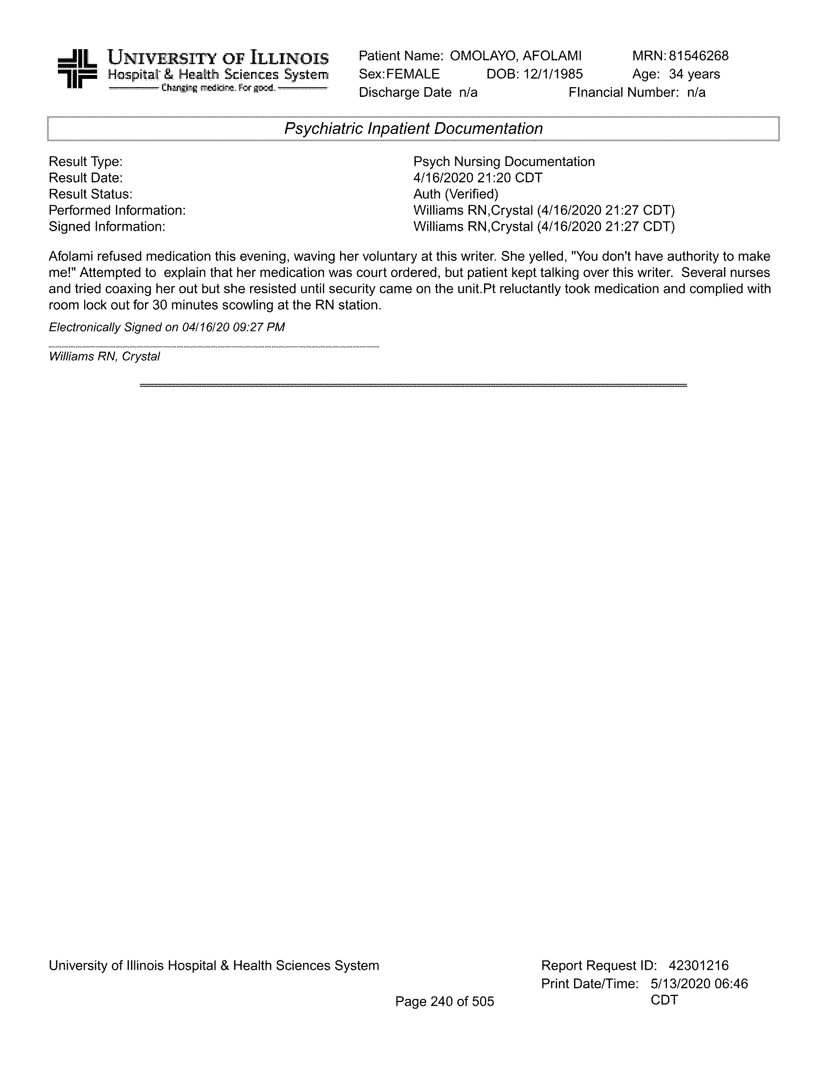

**~~CONFIDENTIALCONFIDENTIAL CONFIDENTIALCONFIDENTIAL~~**

**~~CONFIDENTIALCONFIDENTIAL CONFIDENTIALCONFIDENTIAL~~**

**~~CONFIDENTIALCONFIDENTIAL CONFIDENTIALCONFIDENTIAL~~**

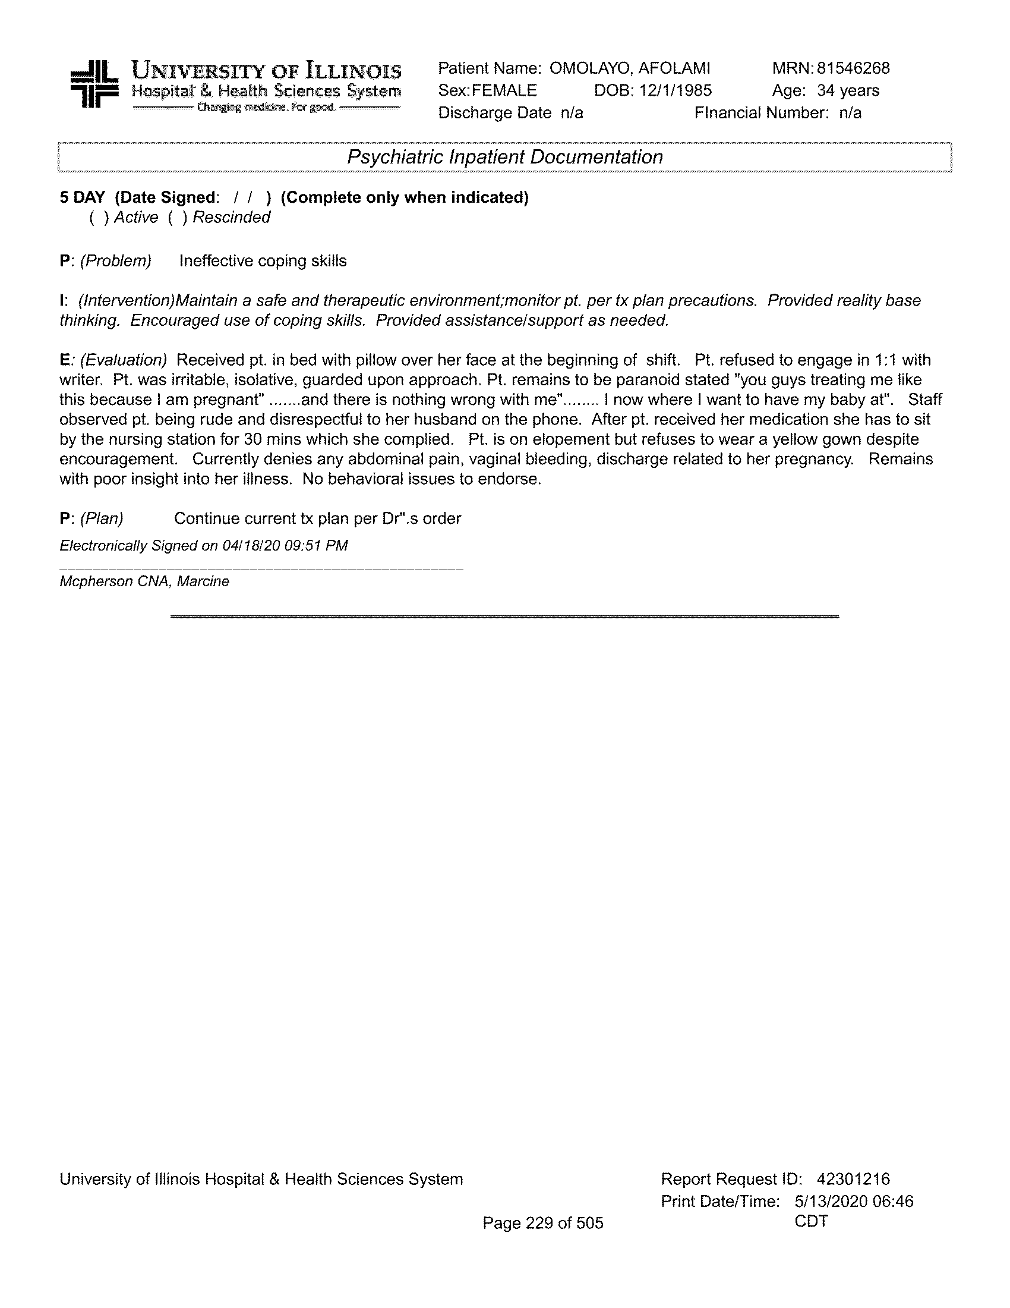

**~~CONFIDENTIALCONFIDENTIAL CONFIDENTIALCONFIDENTIAL~~**

**~~CONFIDENTIALCONFIDENTIAL CONFIDENTIALCONFIDENTIAL~~**

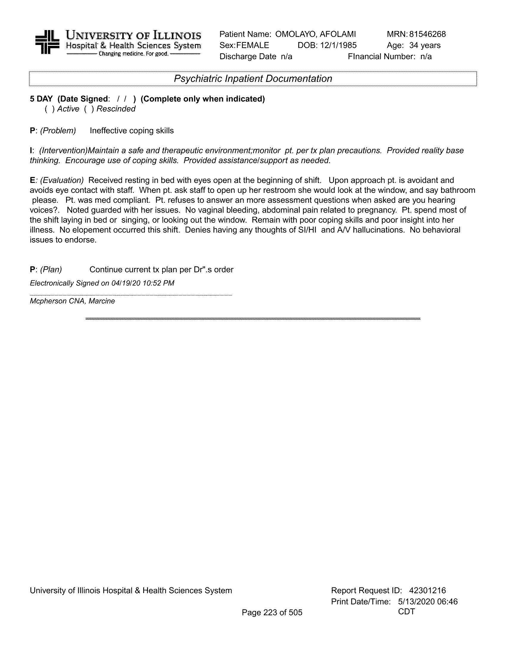

**~~CONFIDENTIALCONFIDENTIAL CONFIDENTIALCONFIDENTIAL~~**

**~~CONFIDENTIALCONFIDENTIAL CONFIDENTIALCONFIDENTIAL~~**

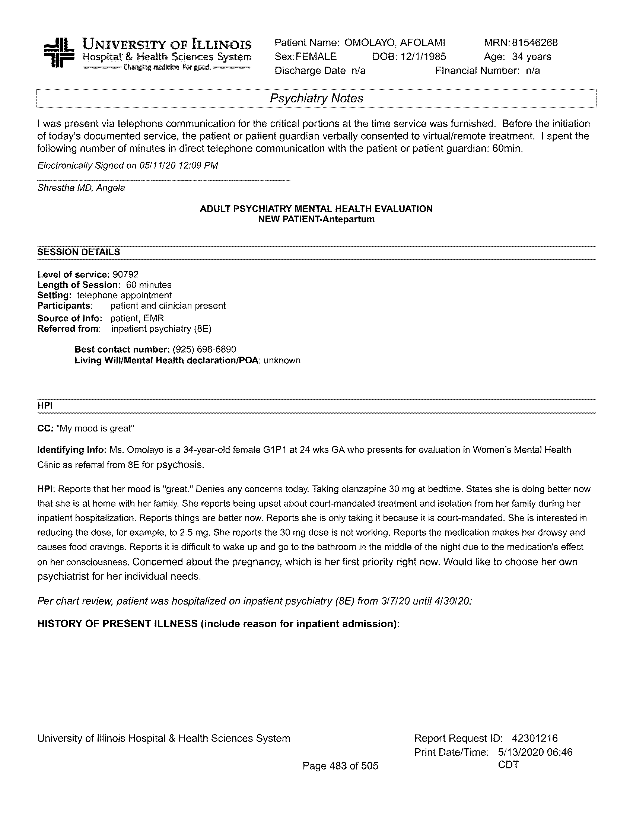

**~~CONFIDENTIALCONFIDENTIAL CONFIDENTIALCONFIDENTIAL~~**

**~~CONFIDENTIALCONFIDENTIAL CONFIDENTIALCONFIDENTIAL~~**

OMFIDECNTIAL

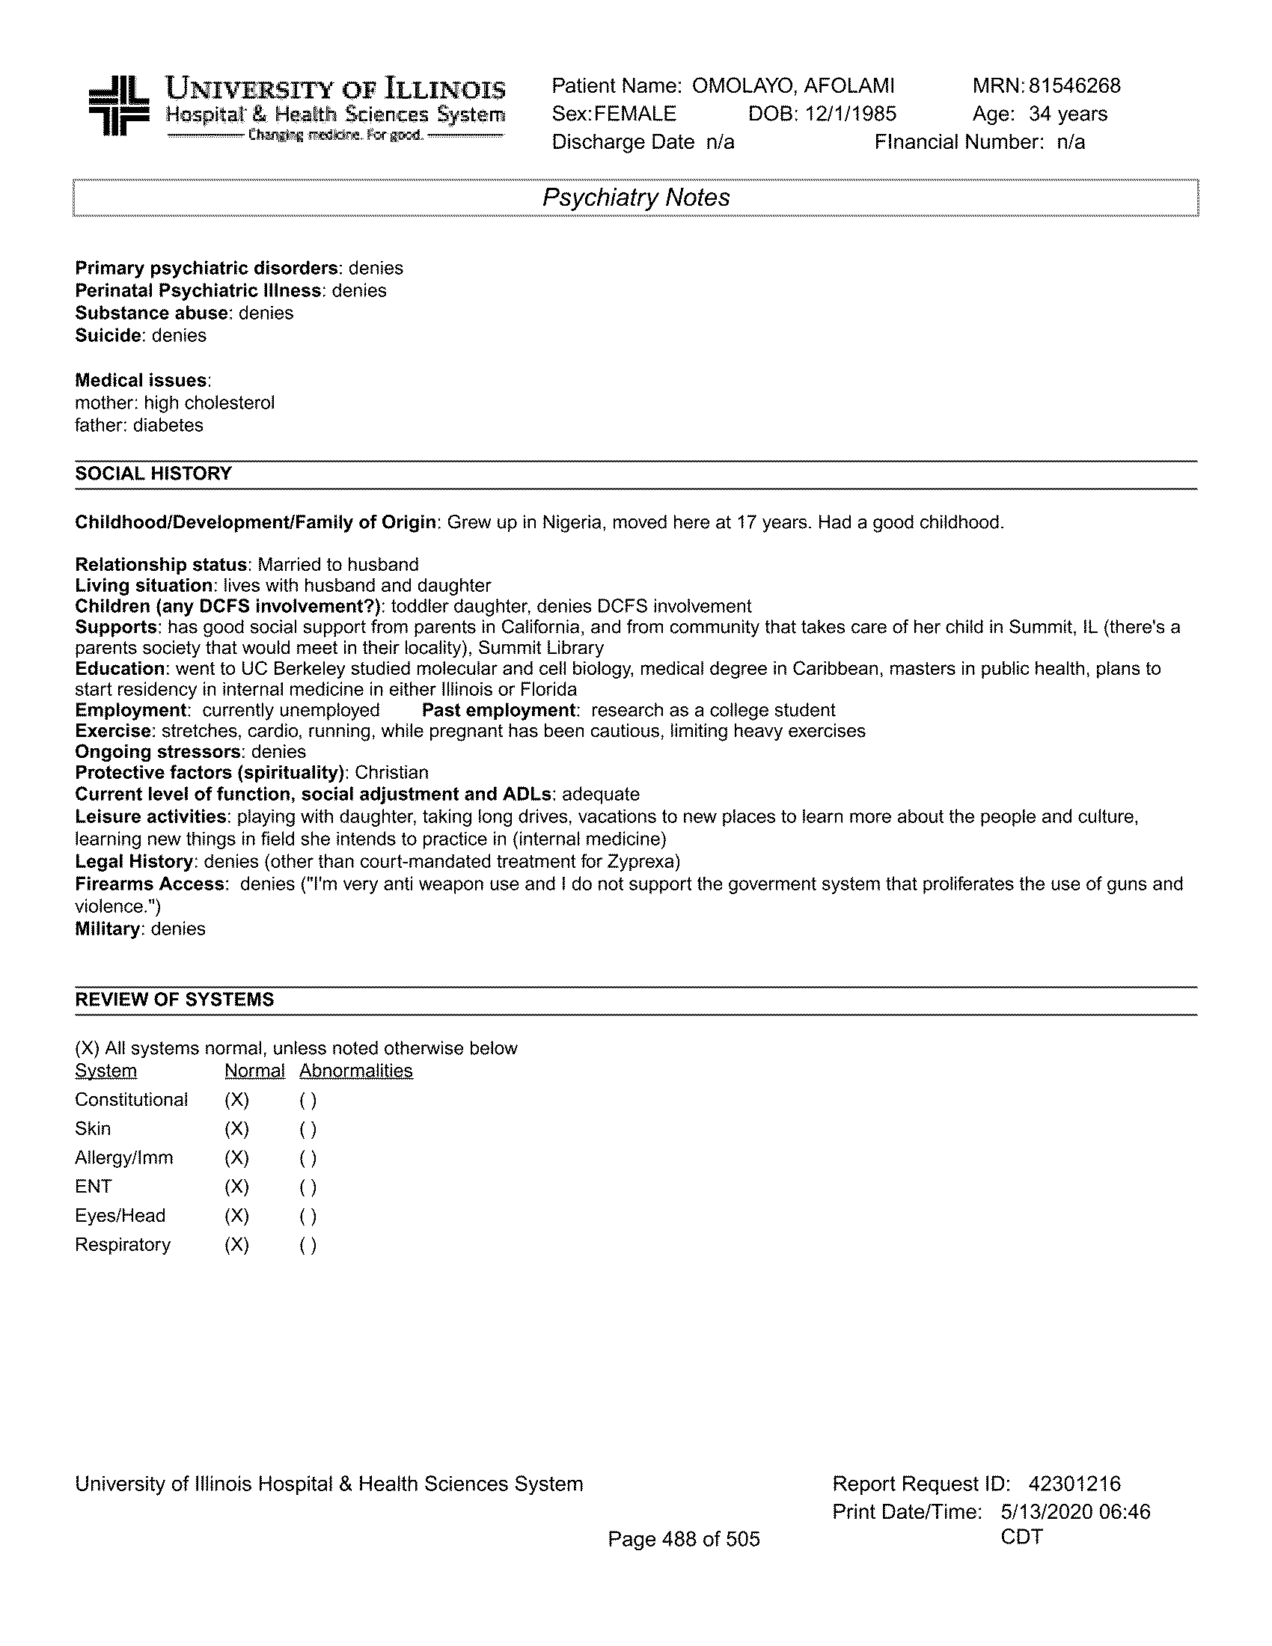

**~~CONFIDENTIALCONFIDENTIAL CONFIDENTIALCONFIDENTIAL~~**

**~~CONFIDENTIALCONFIDENTIAL CONFIDENTIALCONFIDENTIAL~~**

**~~CONFIDENTIALCONFIDENTIAL CONFIDENTIALCONFIDENTIAL~~**